**SENTIMENT ANALYSIS FOR MARKETING**

**OUTLINE:**

* INTRODUCTION
* TYPES
* REQUIREMENT
* TECHNIQUE
* APPROACHES
* INNOVATION IDEAS
* CONCLUSION

**INTRODUCTION:**

SENTIMENT ANALYSIS FOR MARKETING IS THE USE OF ARTIFICIAL INTELLIGENCE (AI) TO IDENTIFY AND UNDERSTAND

THE EMOTIONS EXPRESSED IN TEXT DATA. IT CAN BE USED TO ANALYZE CUSTOMER FEEDBACK, SOCIAL MEDIA POSTS, ONLINE REVIEWS, AND OTHER TYPES OF TEXT DATA TO UNDERSTAND HOW PEOPLE FEEL ABOUT A BRAND, PRODUCT, OR SERVICE.

**TYPES:**

TYPES OF SENTIMENT ANALYSIS

1.*MANUAL* *ANALYSIS*: THIS TYPE USES MANUALLY CREATED RULES BASED ON NEUROLINGUISTIC PRINCIPLES, SUCH AS STEMMING AND TOKENIZATION. IT TAKES A LONG TIME TO SET UP, BUT IT’S EASY TO CHANGE AND CUSTOMIZE.

2.*AUTOMATIC* *ANALYSIS*: THIS TYPE USES MACHINE LEARNING TECHNIQUES THAT USE NEURAL NETWORKS AND

STATISTICAL MODELS TO CLASSIFY LANGUAGE. IT CAN BE CHALLENGING TO CHANGE, BUT IT’S EASY TO SET UP AND MANAGE.

3.*HYBRID* *ANALYSIS*: THIS TYPE USES BOTH

RULES-BASED AND MACHINE-LEARNING ANALYSES. IT’S A BALANCED APPROACH THAT MOST SOCIAL LISTENING APPLICATIONS .

**REQUIREMENT:**

*DATA*: AI-POWERED SENTIMENT ANALYSIS MODELS REQUIRE LARGE AMOUNTS OF DATA TO TRAIN ON

*COMPUTING* *POWER*: AI-POWERED SENTIMENT ANALYSIS MODELS CAN BE COMPUTATIONALLY EXPENSIVE TO TRAIN AND RUN

*DOMAIN* *EXPERTISE*: AI-POWERED SENTIMENT ANALYSIS MODELS NEED TO BE TRAINED ON DATA THAT IS SPECIFIC TO THE MARKETER’S INDUSTRY AND TARGET AUDIENCE.

**TECHNIQUE:**

***NATURAL*** **LANGUAGE** **PROCESSING**(NLP): NLP IS THE FIELD OF COMPUTER SCIENCE THAT DEALS WITH THE

INTERACTION BETWEEN COMPUTERS AND HUMAN LANGUAGE. NLP TECHNIQUES ARE USED TO EXTRACT FEATURES FROM TEXT DATA, SUCH AS THE PRESENCE OF CERTAIN WORDS OR PHRASES, THE STRUCTURE OF THE SENTENCES, AND THE SENTIMENT OF THE WORDS.

**MACHINE** **LEARNING**(ML): ML IS THE FIELD OF COMPUTER SCIENCE THAT ALLOWS COMPUTERS TO LEARN

WITHOUT BEING EXPLICITLY PROGRAMMED. ML ALGORITHMS ARE USED TO TRAIN SENTIMENT ANALYSIS MODELS TO CLASSIFY TEXT AS POSITIVE, NEGATIVE, OR NEUTRAL.

**DEEP** **LEARNING** (DL): DL IS A SUBFIELD OF ML THAT USES ARTIFICIAL NEURAL NETWORKS TO LEARN FROM DATA. DL ALGORITHMS HAVE BEEN SHOWN TO BE VERY EFFECTIVE FOR SENTIMENT ANALYSIS TASKS.

**APPROACHES:**

RULE BASED APPROACH- UNLIKE THE OTHER APPROACHES, THE RULE-BASED APPROACH IS QUITE EASY TO

COMPREHEND. IT BASICALLY COUNTS THE TOTAL NUMBER OF NEGATIVE AND POSITIVE WORDS PRESENT IN THE DATA SET. FOLLOWING THIS, IF THE RESULT INDICATES THAT THE NUMBER OF POSITIVE WORDS IS MORE THAN THE NUMBER OF NEGATIVE WORDS, THEN THE SENTIMENT IS POSITIVE, AND VICE VERSA.

AUTOMATIC APPROACH- IN THIS APPROACH, THE DATA SET IS INITIALLY TRAINED, FOLLOWING WHICH PREDICTIVE

ANALYSIS IS DONE. AFTER COMPLETION OF THIS STAGE, WORDS ARE EXTRACTED FROM THE TEXT. THIS CAN BE DONE

WITH THE HELP OF VARIOUS TECHNIQUES, SOME OF WHICH MIGHT INCLUDE LINEAR REGRESSION, SUPPORT VECTOR, AND NAÏVE BAYES, AMONG

HYBRID APPROACH- AS THE NAME SUGGESTS, THIS APPROACH IS BASICALLY AN AMALGAMATION OF BOTH THE RULE-BASED APPROACH AND THE AUTOMATIC APPROACH. IT DELIVERS MORE ACCURATE RESULTS WHEN COMPARED TO THE OTHER APPROACHES.

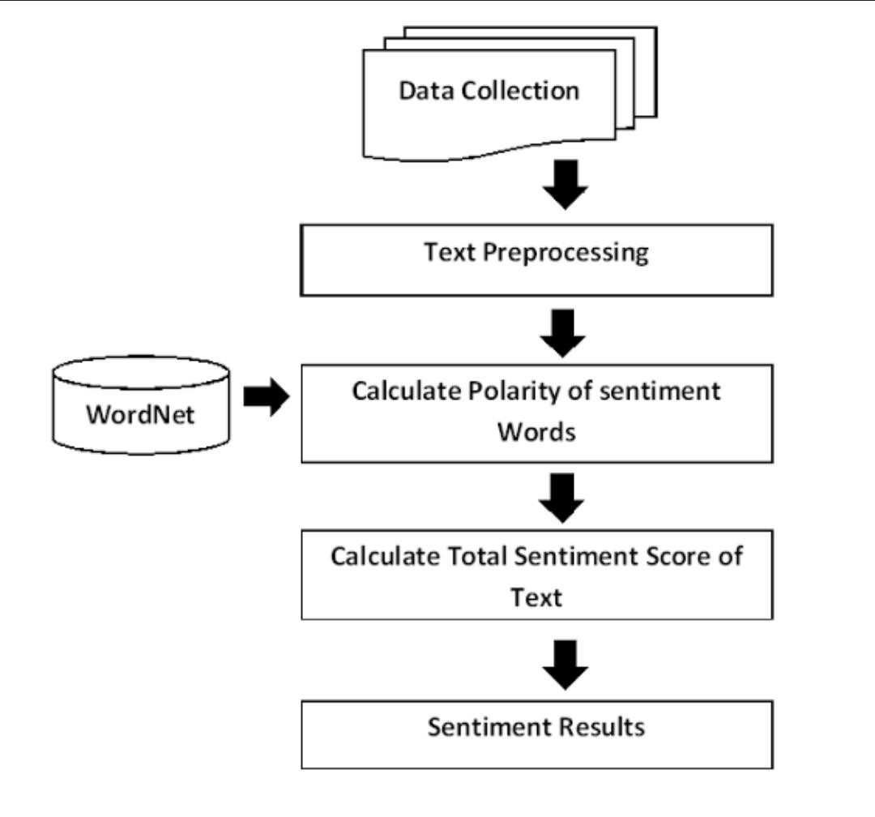

**INNOVATION IDEAS :**

* ONE INNOVATIVE IDEA FOR SENTIMENT ANALYSIS FOR MARKETING IS

TO USE IT TO DEVELOP PERSONALIZED

MARKETING CAMPAIGNS. FOR EXAMPLE, A COMPANY COULD USE SENTIMENT ANALYSIS TO IDENTIFY WHICH CUSTOMERS ARE MOST LIKELY TO BE INTERESTED IN A PARTICULAR PRODUCT OR SERVICE. THE COMPANY COULD THEN TARGET THESE CUSTOMERS WITH PERSONALIZED MARKETING MESSAGES THAT ARE MORE LIKELY TO BE EFFECTIVE .

* ANOTHER INNOVATIVE IDEA IS TO USE SENTIMENT ANALYSIS

TO DEVELOP REAL-TIME MARKETING CAMPAIGNS. FOR

EXAMPLE, A COMPANY COULD USE SENTIMENT ANALYSIS TO MONITOR SOCIAL MEDIA FOR MENTIONS OF ITS BRAND.

WHEN THE COMPANY IDENTIFIES A POSITIVE MENTION, IT COULD SEND THE CUSTOMER A REAL-TIME THANK-YOU MESSAGE. OR, WHEN THE COMPANY IDENTIFIES A NEGATIVE MENTION, IT COULD REACH OUT TO THE CUSTOMER TO TRY TO RESOLVE THE ISSUE.

**CONCLUSION:**

THE FUTURE OF SENTIMENT ANALYSIS FOR MARKETING INNOVATION IS VERY BRIGHT. AS AI TECHNOLOGY CONTINUES

TO DEVELOP, WE CAN EXPECT TO SEE EVEN MORE INNOVATIVE WAYS TO USE SENTIMENT ANALYSIS TO IMPROVE THE CUSTOMER EXPERIENCE AND MARKETING RESULTS.